(1) Write out the numeral million, hundred thousand and .

(2) Evaluate:

(3) Evaluate: 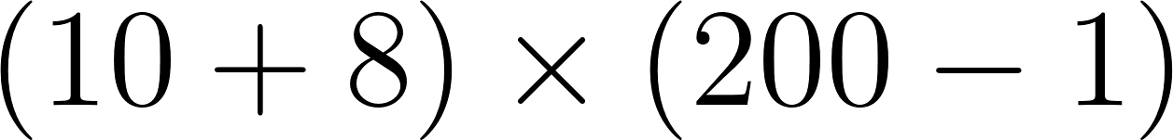

(4) What is the perimeter of a square with side length 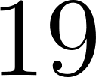 ft?

(5) Yoyo constructed a large square using small white square tiles of uniform size. Tom painted all tiles on the edge of the large square black. Shelly counted 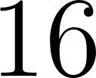 tiles that were painted black. Shelly then painted every tile on the diagonals yellow. How many tiles were painted yellow but not black?

(6) Rochester Math Club buys pies for students and their parents for the math festival. Each pie costs dollars. The club plans to spend 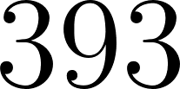 dollars on pies. After students each eat pie, how many remaining pies are left for their parents?

(7) Triplets Jack, Jim and Jill went to the market. They each brought the same amount of money with them from their mom. Jim spent exactly 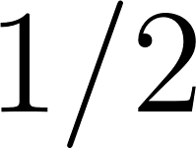 of his money, while Jill spent twice as much as Jim and Jack spent half as much as Jim. What proportion of money did they bring home all together comparing to what their mom gave to them? Answer in the simplest fraction.

(8) Evaluate the value:

(9) Four children (Sue, Ray, Joe, Tim) have their own favorite dinosaur among the T. Rex, Stegosaurus, Brachiosaurus and the Triceratops (no two children like the same dinosaur). Here are four clues helping you figuring out their respective favorites:
1. Sue's favorite dinosaur's name does not start with a "T."
2. Ray's favorite dinosaur's name ends with an "s."
3. Joe's favorite dinosaur's name has eleven letters in it.
4. Ray's favorite dinosaur does not have a "c" in its name.
What dinosaur does Tim like?

(10) Jack gave Jill some flowers. To figure out how many flowers Jack gave, there are clues:
- Jack gave Jill an odd number of flowers
- There is only one way of further divide the flowers into bundles of equal numbers of multiple flowers (each bundle have at least two flowers).
- The digit 5 appears once in the number.
- The number is less than .
What is the number of flowers that Jack gave Jill?

(11) In the magic square below, the numbers in each row and each column add
up to the same sum. Find the value of .

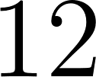
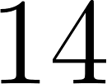
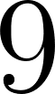

(12) In Figure 1, you can see that SEE + BEE = FLEA. Each distinct letter represents a different digit from 0-9. The same letter represents the same digit. Find the sum of F, E and A.
SEE
BEE

FLEA
Figure 1

(13) How many digits of are there in the results of the operation:
( digits of , followed by digit of )

(14) Find the sum of digits a and b, given a and b are distinct single digit make the following fractional expression true: 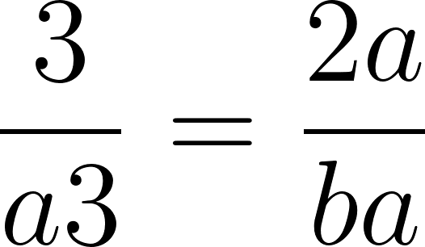. (Note two digits represent a two digital number with a 10’s place value followed by a 1’s place value).

(15) What is the smallest positive integer with a digit sum of 314? (Digit sum means treating numbers at different place values as single digit number and then add them together. For example the digit sum of 1234 is 10, since 1+2+3+4=10)
P.S. The answer is a large number, you don’t need to write all digits down, please write down the first and last digit clearly, and use … for repeating digits in the middle, specify how many digits are omitted by …)

